**SLEI Research Data Task**

**Instructions**: For this task, you may use any tools that you like. Please share all of your results, answers, and code in a way that is clear and professional. Furthermore, be prepared to edit and run some of your code “on the fly” with screen sharing enabled. We anticipate the task should take about one hour. We encourage you ***not*** to spend time making the chart output particularly “pretty” just for time’s sake. We will be focusing on your approach, results, and thinking about what other related research could provide interesting insights.

Here are the data: <https://drive.google.com/drive/folders/1qhWSFJRQ3vMkwab85bhLt9T4pHVp1J_7?usp=sharing> , Sean Lahman's Baseball Databank, with information like salary, players who have been admitted into the Hall of Fame, player weight, and of course, baseball performance.

**Q1**

You've been asked to evaluate the Hall of Fame status of players as a result of country of origin for SLEI Faculty Advisor, George Foster (not likely, but he does like baseball). You decide to make a plot of players in the hall of fame over time, grouped by each country. Your end result should look something like this:

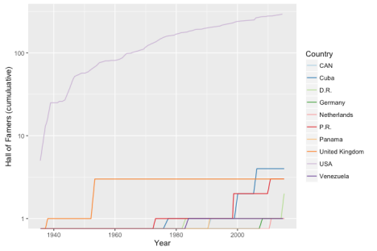**Q2**

After making this graph and giving it back to George, what questions and/or observations would you bring up? Are there any interesting research questions or findings you would explore further?

**Q3**

The data in the “Baseball Databank” currently exist as multiple csv files. Create a plan to centralize these data. What data management tools would you leverage (or build) in order to house and easily manage all of these growing data?

**Q4**

How might you go about setting up a research program to study the challenges and opportunities facing U.S.-based baseball players from different countries?